Basic Network Hardware Theory
- Log in to your home Wi-Fi router's admin panel using its default IP address (usually 192.168.0.1 or 192.168.1.1) and take a screenshot of the login page. Hint: If you don't know your router's IP, open Command Prompt and run 'ipconfig' — look for 'Default Gateway'.
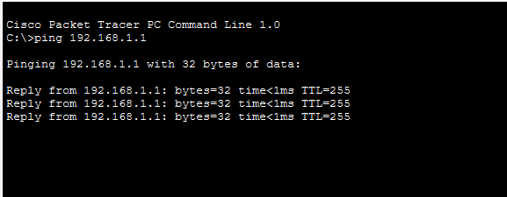
Fig 1. Testing that both devices are communicating
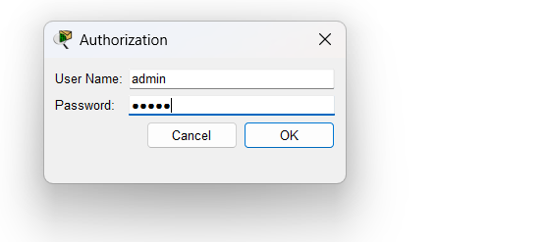
Fig 2. Authorization to access admin page of router
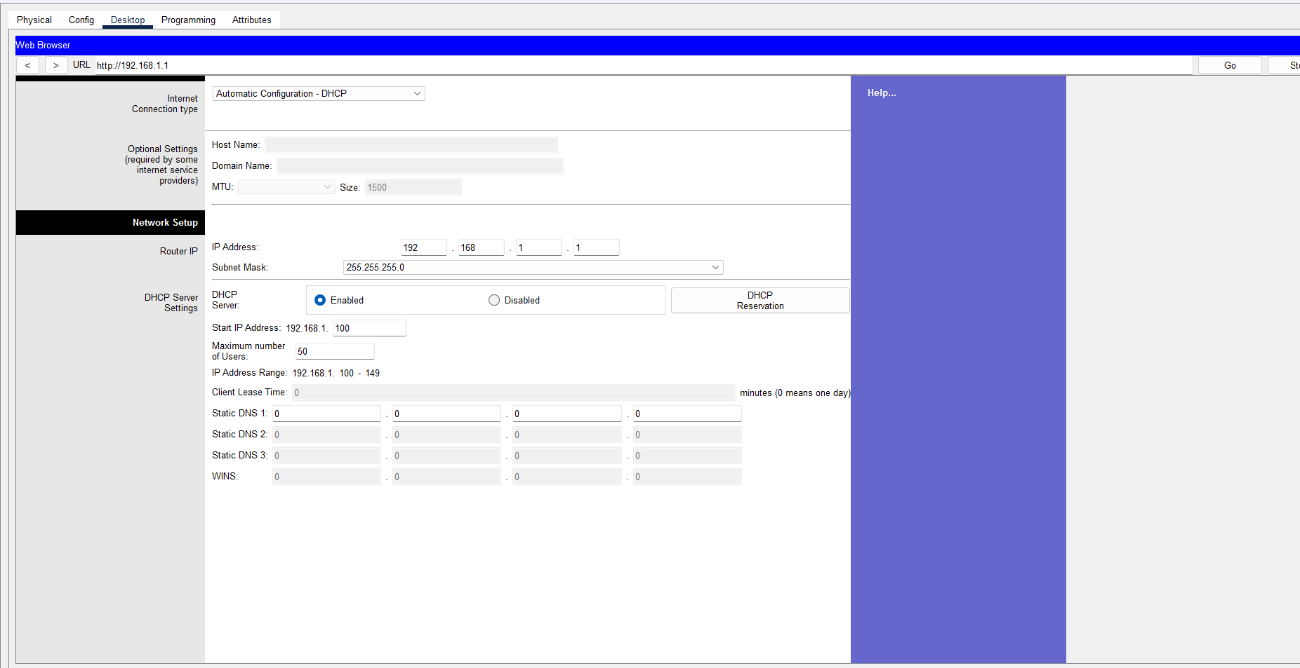
Fig 3. Router admin page
1. Connect Devices
- Connect PC → Router using Ethernet cable.
2. Set Router IP
- Router IP: 192.168.1.1
- Subnet Mask: 255.255.255.0
3. Configure PC IP
- Give PC a static IP:
- IP: 192.168.1.10
- Mask: 255.255.255.0
- Gateway: 192.168.1.1
4. Test Connection
- Open Command Prompt.
- Type: ping 192.168.1.1
- If you get "Reply", PC is connected to the router.
5. Open Router Page
- Open Web Browser.
- Enter: http://192.168.1.1
6. Login
- Enter router username and password.
- Open router settings page.
7. Check Settings
- Verify:
  - Router IP
  - DHCP status
  - Wireless name (SSID)

- Find and note down the current IP address, subnet mask, and default gateway assigned to your laptop or mobile device when connected to your Wi-Fi network.

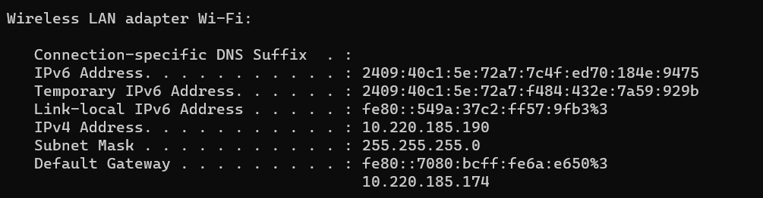
Fig 4. Current IP Address, Subnet Mask, Default Gate way of my mobile device

- Change your device's IP address from 'Obtain IP automatically' (DHCP) to a static IP in the same range as your router (for example, set it to 192.168.1.50 if your router is 192.168.1.1), and test if you still have internet access. Constraint: Remember to revert to automatic/DHCP after testing to avoid network issues.

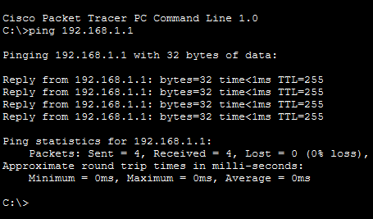
Fig 5. DHCP Configuration result
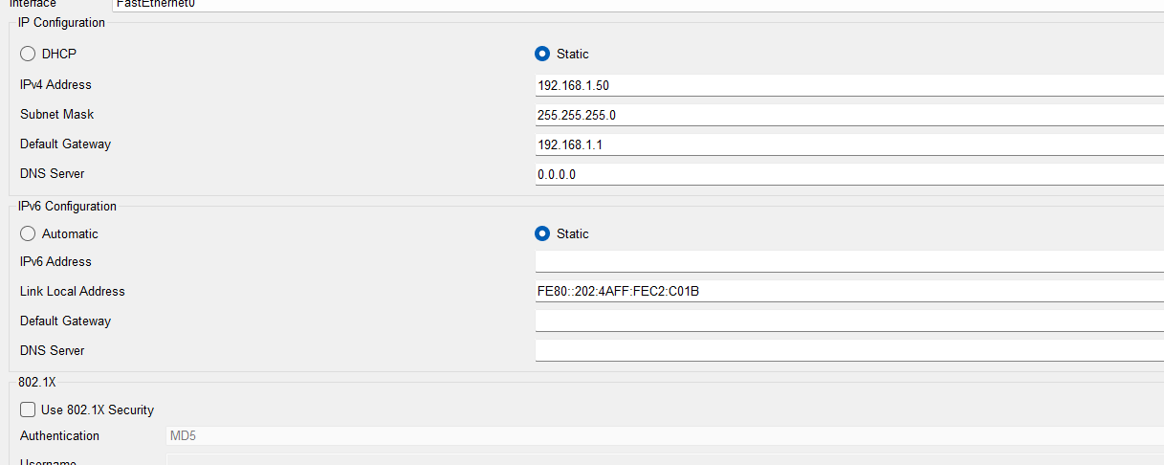Fig 6. Static IP Allocation
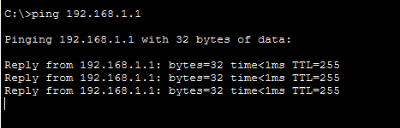
Fig 7. Static Configuration Result

- In your router's admin panel, locate the section where you can view or change the DHCP range. Write down the current range, and explain in 2-3 lines what would happen if two devices are assigned the same IP address in this range.

If two devices are assigned the same IP address, an IP address conflict occurs. Both devices may face communication problems and may not be able to access the network properly because the router cannot identify the correct device.

Current Range is: 192.168.1.100 - 192.168.1.149. – 50 Devices
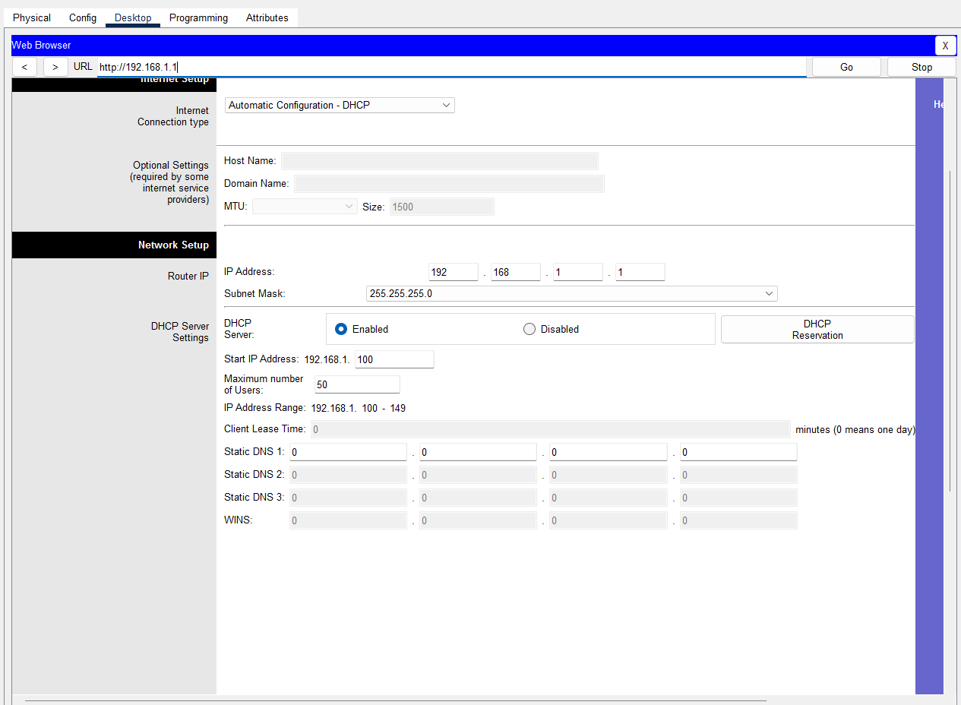
Fig 8. Accessing router admin page

